Conception
In his history of the Second World War, Winston Churchill mentions that President Roosevelt wrote the following to him on the 25th of October 1943……

President Roosevelt to Prime Minister. It is a nuisenza to have influenza. No word from Uncle Joe yet. What say we next meet in North Africa soon….

This date was exactly nine months before I was born, so it can be assumed that while my parents were conceiving me the most powerful world leader was sneezing.
I make this connection partly because a children’s primer on sex that I read later on in life informed me that an orgasm was like a good sneeze. Illogically, instead of procreating, most of the world was intent on killing at this important moment. Yet, to their credit, belligerents making up the two camps were at least making some effort to work in unison. As Roosevelt’s letter indicates, he and Churchill were planning a meeting to better co-ordinate the war efforts of the Allies, but coincidently at much the same time, the two principal Axis powers, Germany and Japan, were also undergoing a difficult but successful combined operation.

In the Indian Ocean, and less than a hundred miles away from the Mauritian bedroom where I was probably conceived, Subhas Chandra Bose, the charismatic president of the Indian Independence League, was transhipped in a rubber dingy from U-180 to I-29, a Japanese submarine, to take command of 40,000 Indian soldiers who had switched sides following Britain’s defeat at Singapore.

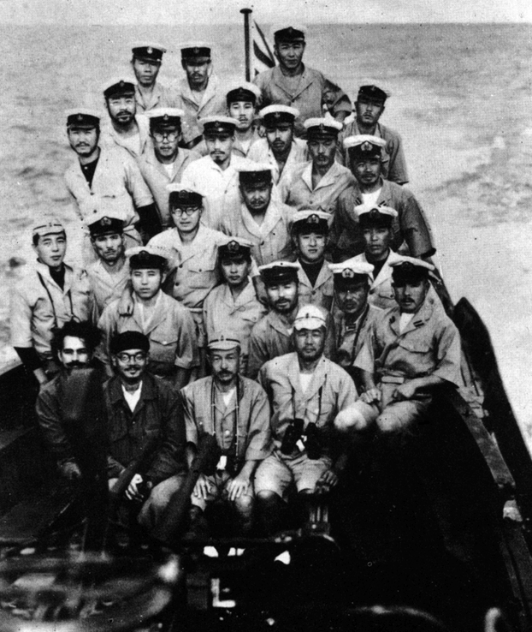
Bose is second from left in the front row on I-29. He had just been transferred from a German submarine.

Birth

However in spite of these efforts, by mid-1944 things were going rather badly for the Axis. Bose and his army failed to rise to expectations. Adolph Hitler was nursing a sore arm and suffering from ringing ears, having recently just missed being blown up at his Rastenburg headquarters by a bomb left under the table by Colonel Claus Schenk Graf von Stauffenberg.

Like the Fuehrer, my mother was preoccupied. She was in labour, and he was concerned about the bad war news. (The American 1st and 3rd armies had broken out of their Normandy beachhead and had begun surging through France west of Saint-Lo.) Like these American GIs, I was anxious but relieved, and emerged from my enclosure with loud defiant cries. According to my birth certificate, I was born at four o’clock in the morning at Rose Hill on 25 July 1944 in the District of Plaines Wilhems. My father was the “informant” and the witnesses had the intriguing names of Ramnehur Gargoolre and Jules Baillauche.

The ticket below is my father’s pass to enter the dock area of Port Louis on 9 August 1945 and have our luggage examined before we embarked on the ‘Franconia’.
The Japanese did not surrender until 15 August.
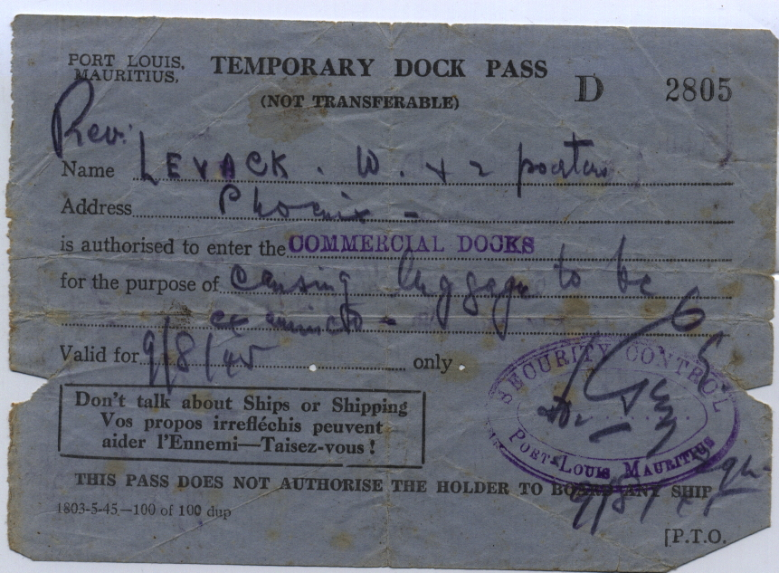
Note the French exhortations: “Your thoughtless remarks can help the enemy.
Keep quiet”, and on the reverse below: “Walls also have ears. Too much talking can kill”

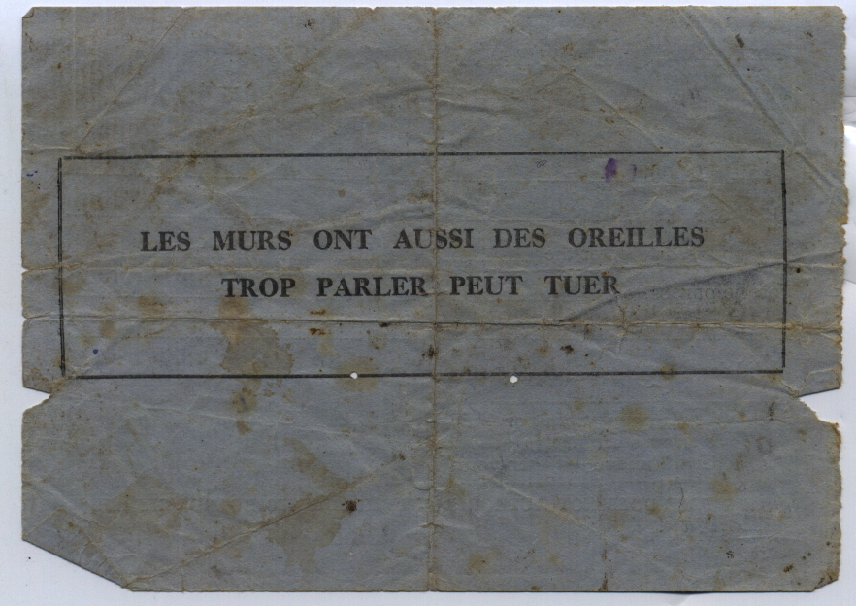

Mauritius to Scotland.

Before my first birthday Roosevelt, all the crew of I-29, Hitler, Von Stauffenberg, Rommel and tens of millions of other World War II combatants that had been alive when I was conceived were dead. Bose, not to mention most of the citizens of Hiroshima and Nagasaki were soon to follow.

After VE day, my father William Larnach Levack, took my mother, Deborah (née Mayer), my elder brothers, Alexander and John, and me to Scotland to meet his mother, Elizabeth Levack (née Henderson) for the first time. We travelled on the SS Franconia via the Suez Canal and then Haifa, Palestine. It was rather trying for my parents. Japan was still holding out, and the Franconia would have been torpedoed had a Japanese submarine sited it. The women and children were segregated from the men, the ship was overcrowded, and we all caught impetigo, boils, scabies and lice. When we disembarked at Liverpool my aunt Joan joked that we looked like the pictures she had recently seen in the newspaper of rescued concentration camp inmates.

First memories at Burghhead.

My father, who was a clergyman, was appointed to the parish of Burghead that lies on a promontory on the south side of the Moray Firth.

Burghead village was an important Pictish fortification during the iron-age. The remnants of this fort were largely demolished and transformed into a pier in the 1800s. My first clear memory was of standing on that pier with my father, at the age of three, and watching a hammer-head shark consuming offal that had been dumped by a returning trawler. This memory was reinforced by my father, who frequently reminding me of it. The size of this Jungian monster must have made a major impression on him too.

Exposed to North Sea Gales and living at higher latitudes than Moscow, we would have experienced bleak weather in Burghead anyway, but the winter of early 1947 turned out to be the coldest ever recorded for Scotland. It did not help that fuel as well as food was still being rationed.

Consequently, when my father was offered the job of being chaplain to the British troops, and Minister at St Columbia Church, in Mauritius again he quickly accepted.

Scotland to Mauritius.
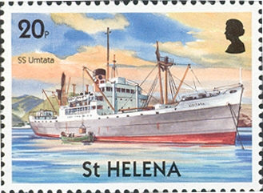
We returned to Mauritius on the SS Umtata in 1948. At first we lived in one of the Army Garrison houses at Vacoas, and then we moved into a bungalow at Cemetery Road, Phoenix. It had ornamental wooden spikes attached to the gables of the roof. They fascinated me because my father, without revealing that he was joking, said that they were constructed that way to impale enemy parachutists.

Europeans were expected to help generate employment by hiring servants. An old French Creole woman called Germaine was taken on as our cook and her daughter, Déa, did the housework. Déa lived with her husband, Doodoo, in an old shack at the back of our house known as the “dependance”. There was no laundry. Our clothes were washed by hand in the local river by Indian dohbis.
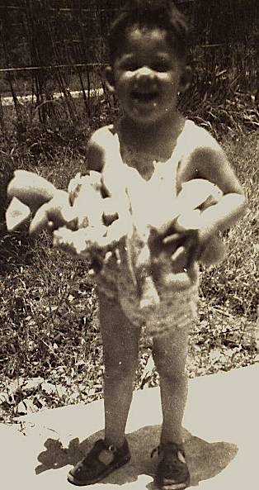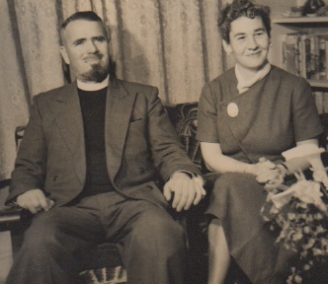
Me about 1948 My father and mother about 1960

Brown pudding and the polio epidemic.

Germaine’s grandparents would have been born into slavery, but she was in charge during the evenings when my parents went out. On these occasions Alexander, John and I would eat dinner around a small table that happened to have drawers at either end. Germaine would serve up copious helpings of food and get annoyed if we did not finish everything placed in front of us. She had a strong sense of responsibility, was maybe in her sixties or seventies, was a little deaf, spoke limited English, and was difficult to reason with. At the age of four I recall solving the problem of not wanting to eat Germaine’s brown pudding by tipping it into one of the table’s drawers. Soon Alexander’s and John’s brown pudding had gone into the drawer too. “Bien fait”, said Germaine, who thought we had consumed every spoonful without any of the normal fuss, and sent us off to bed.

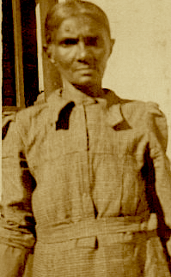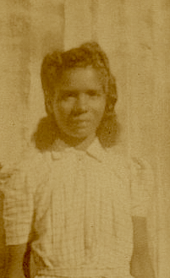
Germaine and Déa about 1951

Meanwhile there was a polio epidemic in Mauritius and the authorities closed all the schools to minimise the chances of infection. Although I was not yet a school pupil, this pleased me because I would have the company of my brothers during the day and be allowed to watch and imitate them doing the school-work that had been set. I would scribble numbers and letters that were frequently back-to-front, upside-down, then mark them proudly with ticks or crosses.

In addition we had the benefit of visits from an attractive young female teacher who toured her pupils’ homes to encourage studying. Impressed by my precocious enthusiasm she allowed me to sit at the table while she taught my older brothers.

At one point she must have wanted to correct John’s spelling and she reached into the drawer under the table to find a pencil. Her hand went into the brown pudding, which, by then, was more like a small heap of fructifying shit.

Racial Discrimination.

There was a lychee (Litchi chinensis) tree in our Phoenix garden that was easily climbed and produced yummy red berries. One day while reaching too far I fell out of the tree. My forearm struck a stone on the ground, and I ran inside the house howling. My father decided that he would take me to Candos Hospital to see a doctor because I would not stop crying. On arrival we attached ourselves to a slow-moving queue of black patients. By then my arm was not hurting so much. In fact I was quite enjoying having my father to myself, but before long we were noticed and ushered up to the front of the queue. Even at the age of five I was aware of the concept of waiting one’s turn, and pointed out that the others should have priority
“Don’t worry”, said the doctor as he put my broken arm in a splint, “Time is not so important to those black fellows.” This was odd since the doctor himself was not quite white.

I was starting to appreciate the complexities of human social interaction.

Little removed from being a slave society, a strong racial stratification still existed in Mauritius. Authority and status was associated with being white so an octoroon held a superior position to a quadroon and so on. Other sorts of discrimination existed as well, but by being white, well educated, secure financially, and British, my father was near the top of the pile. As the one and only representative of the Church of Scotland he was equal to the Anglican Bishop of Mauritius in order of precedence. Because he was also chaplain to the Garrison he was ranked equal to a Government Departmental head. The Governor, Sir Hillary Blood, (who was the most important person in the colony), was a Glasgow university graduate like my father. Both believed that the Empire was fortunate indeed to count Glasgow University graduates among its administrators and councillors. Consequently my parents were often invited to dine in Government House at Reduit.

My mother had good credentials too. Not only was she white, attractive and British but she also had “grand blanc” French ancestry. Her father’s family (the Mayers) had intermarried with the De Chazals who owned one of the largest sugar estates in Mauritius. At emancipation in the 1800s the De Chazals had been handsomely compensated for their property loss, i.e. their slaves who worked the St Antoine family plantation. In the 1950s the Mauritian working class, most of whom were descendants of slaves, or the offspring of indentured Indian labourers, would have been treated reasonably well under the prevailing industrial laws but they were still disenfranchised.

My mother’s view, now politically incorrect, was that slavery was not necessarily an entirely bad institution. She believed that providing they had kind masters, slaves were in many ways better off than their progeny were today because the owners looked after them if they were old or sick.

Greed and Gullibility.

One day Alexander suggested that he and I go prospecting. As my brother was 100 percent older at the time, and much admired by me, I eagerly accepted this unusual invitation to accompany him. We toured the garden with a bucket and spade. Various soil samples were collected and dumped in a row by the outdoor tap. He explained that it would be necessary to wash the soil until stones appeared. He assured me that if I then washed the stones long and hard enough gold would emerge. It would be obvious because it would glint in the sunlight. Before going off to read a Beano comic he explained that if I did all the work I could have half of the treasure that would be produced.

I stuck to my job by the tap, turning the garden into a bog and covering myself in mud, until ordered by my mother to desist.

Alexander had made me an object of family amusement. This gave me an early appreciation that a nil return on investment and derision can follow if one does not think things through for oneself.

Power structures.

My mother thought that I would enjoy feeding the fowls we kept. Indeed, having the power to dispense grain to grateful chickens did give me, at bottom of the family pecking order, a satisfying feeling of importance. However the rooster, only a little less tall than me, considered I was challenging his status. He flew at me, and pecked my eyebrow. Dropping the plate of grain, I ran screaming and bleeding into the house. That night we had chicken for dinner. Having noticed the recent absence of the cockerel, brother John was first to work out what had happened and leave the table in distress.

This was yet another lesson for me. I had learnt that while power is gratifying, others, who have less, usually wish they had it instead and, given the opportunity, there will always be someone around who is prepared to go to quite surprising lengths to diminish your status.

Yet I did not blame the rooster. Being pecked seemed to me to be just another one of life’s many hazards, like falling out of the lychee tree or getting scabies. Execution was an over-reaction. Clearly one could not expect justice in life. My mother thought otherwise. She believed I was lucky the rooster had mistaken my eyebrow for my eye.

The King’s African Rifles.

A Kings African Rifles (KAR) battalion was garrisoned in Mauritius at the time so my father had to learn KiSwahili to preach to them. Idi Amin who later achieved notoriety as President of Uganda was a sergeant in the KAR at about this time. My father said Idi might have been one of the NCOs that sat in the front pew of our church. This is unlikely because he was a Muslim but there is no doubt that being in a church full of these large black fellows lustily singing “Asante sana….” in their No 1 uniforms with shiny brass buttons and medals was very rousing.

Cute in my Sunday kilt and spectacles, the attention was reciprocal, especially when I prattled off four words of KiSwahili that I had learned from my father in the appropriate order.
“Jambo” [Hello]
“Habari” [How are you?]
“Mzuri” [I am fine thanks]
“Kwaheri” [Goodbye]

[Forty years later my aunt Helen in Kenya taught me another KiSwahili word “Toka” which means “Piss off”. This is a really handy expression to use when pestered by hawkers in Nairobi.]

The KAR looked and sounded even more splendid on the parade ground. A warrant officer wearing a leopard skin and swirling a decorated staff would lead, followed by a dazzling band that included a base drummer, a couple of kettle drummers and other soldiers blowing shining brass instruments. Then, in perfect step, came rows of askaris, each with a red fez on his head, one arm swinging and the other shouldering a 0.303 rifle.

My mother used to teach the soldiers’ wives sewing. While accompanying her to the army barracks I learnt another KiSwahili phrase which was, “Shona kidogo, kidogo” meaning sew with small, small, stitches.

My father also had to preach in French to another one of his Mauritian congregations.
Later when we went to Waipu, New Zealand he preached in Gaelic. [More about this later]

Eventually I inherited bibles in Swahili, Hebrew, French, Greek, Gaelic and English from him, giving me clear one-upmanship over any Jehovah’s Witness that arrives at my door asking if I have a Bible in the house.

Legless.

Under his trousers my father concealed a mysterious mechanical devise. He learned to walk on this prosthetic following the amputation of his lower left leg in 1949. To begin with he would stagger a few steps across the lawn, and then surprise me by suddenly falling on his face. When he did this I would clap my little hands with enjoyment. He would then try again.

My mother told us that daddy did not like talking about his artificial leg and we were not to talk about it either. We accepted this as perfectly normal.

When I returned to Scotland in 1967, my uncle James Levack, who was a surgeon, asked if my father had had any problems with his leg since the amputation. I said I did not think so and asked James if he knew exactly why the leg had been cut off. As my uncle had been involved in getting a second opinion for my father, he not only knew, but he still had the biopsy record that diagnosed the cancer as a fibro sarcoma, a fairly rare disease of the connective tissue.

Fortunately my father never had any recurrence of the cancer although from time to time, if he over-did his walking, he experienced problems with sores on his stump that took a long time heal.

A different problem arose one day in Whangarei. The leather fastenings to his prosthetic, which had been rotted by years of sweat, gave way and suddenly he found himself horizontal on the footpath. My father had to crawl to his car, which fortunately was not parked very far away. His main concern was that some of his parishioners might see him and think he was drunk.

First day at school.

My father advised me to stop sucking my thumb otherwise I would get teased.
Apart from abandoning this comfort, my first day at the Mauritius Garrison School went off well. Lena Drybrough-Smith taught the new entrants, and her husband, Captain Drybrough-Smith, taught the more senior classes, which included my brothers. Captured at Dunkirk, he had caught tuberculosis as a prisoner of war, and was still only fit for light duties, so he too had completed a teacher-training course. The Dryborough-Smith’s had a daughter, Helen, who was the same age as Alexander and another, Jane, who was a bit younger than me. The Dryborough-Smiths were family friends so Lena was particularly nice to me, that is, until she found me encouraging Jane to play playing doctors and nurses.

Cyclones

With the diameter of their circular motion often being as great as 500 km, tropical cyclones travel from the equatorial belt of calms where they form, then curve away from the equator accelerating as they go. Apart from their forward speed they feature spiral winds that blow inward with a tremendous velocity that sometimes approach 300 k.p.h. The centre of the swirl is also the centre of lowest pressure and is called the “eye of the storm”. When the eye arrives the winds drop suddenly, the torrential rain stops, the clouds often break leaving clear sky and at sea the waves become confused and pyramidal.

Annually Mauritius is subject to cyclones. They are welcomed if they brush past the island because they provided the sugar plantations with much needed rain. However if they went over the island they would tear up the sugar cane and flatten buildings, whip away roofing iron and cause fatalities.

Usually the Meteorological service was able to warn that a cyclone was coming a day or so in advance. Such events were exciting. The special wooden shutters that were part of all Mauritian windows would be swung over and fastened. Necessary emergency supplies would be purchased. The family would then hunker down together, listening to wind getting stronger and stronger, light candles when the power went off and start consuming the store of chocolate and other treats.

My father said that once he went outside to ascertain damage during the eye of the storm. He found that the wind had picked up the family car from its place on the drive, pointed it in the opposite direction and placed up side down in the vegetable garden. However, after the cyclone completed its passage, he went out again to find that the opposite winds had picked the car up from the vegetable garden, turned it the right way up, and placed it back where it originally had been.

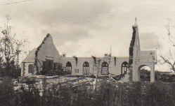
Our Church, St Columba, Mauritius, after Cyclone Carol.

Mauritius to New Zealand.

In February 1952 my father’s job came up for renewal. He could have remained but circumstances had changed. My parents thought that they should set up in a place where there was a better future for us children. Somewhere that could provide Alexander with a good secondary education was needed. There was a mutual dislike between my father and his mother-in-law, who by then was living in London. He did not want to live too near to his dominant Glasgow-domiciled mother either so this ruled out Britain. Canada was considered, but somewhere warm was preferred. A New Zealand brochure showing a scantily-clad wahine standing by a nikau palm tree on a sun-drenched beach inveigled my father into believing that our destination should be New Zealand.

Accordingly berths were purchased to leave Mauritius on the Dutch ship, MV Tjsidani. As it turned out we were obliged to depart a day earlier than planned because of a cyclone warning, ships in harbour being more likely to incur damage from cyclones than in the open sea.

The door of the cabin I was to share with my brother John had a three inch steel lip that you had to step over to get in. We enjoyed the novelty of putting our clothes into the nice little varnished wooden lockers, and then we went to the dining room for a hearty dinner. My brother promptly regurgitated his. This was a portent of worse to come. Loud thudding sounds below my bunk woke me up that night. Waves breaking over the ship meant that water had even got into our cabin, converting its floor into a square pond as the rest of the water drained out. Empty suitcases that had originally been placed below the bunks were now floating and were crashing back and forth against the cabin walls as the ship pitched and rolled in the seas that were now enormous. The Tjsidani had run straight into the path of the cyclone and was being flung about by giant waves that sometimes completely engulfed her. My mother insisted that we huddle together in her cabin so that we could console each other as we drowned en famille. On the way from my cabin to hers I recall looking several floors down the stairwell that was tipping at a crazy angle, and seeing water sloshing around at the bottom.

Several davits, steel railings, and air-intake structures were buckled but the Tjsidani’s heavy keel and watertight bulkheads kept the ship from turning turtle. The 60-year-old Dutch captain said that in all his years of service he had never before experienced such terrifying seas.

The Tjsidani dog-legged to East Africa to drop off and pick up cargo, then headed for Singapore. I remember the smell of cloves that pervaded the wharves at Zanzibar, and visiting the Sultan of Zanzibar’s Palace with my father. My mother was not allowed to accompany us because she was a woman.

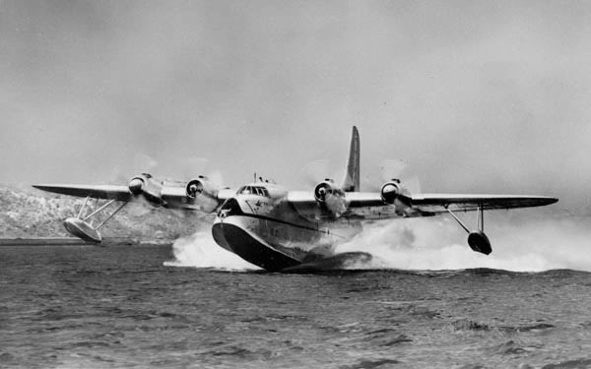
When we arrived at Singapore flags were flying at half-mast because King George VI had died. Of more significance to the family was the news that the ship we were supposed to connect with in order complete our journey to New Zealand had already departed. We did not have enough money to stay for long in a hotel, but my father contacted a fellow Church of Scotland clergyman, the Reverend Greer, who offered to put up our family in his manse until something was sorted out. About a week later we embarked on a Qantas DC3 from Changi airport to Sydney. After a couple of days in Sydney we took off for Wellington on a TEAL (Trans Empire Airways Limited) four propeller Sunderland Flying Boat (called the RMA Aranui). Landing in Evan’s Bay on 18 February 1952 we were met by Mr Horwell, the administration director of the Presbyterian Church.

Three advantages of being in New Zealand impressed us immediately. One was the ready availability of ice cream, a rare treat in Mauritius where dairy products were likely to carry typhoid and few people owned refrigerators.
Now we could stop at any corner shop and buy Tip Top in a cone. Another joy was being able to walk around outside without shoes, something that we were forbidden to do in Mauritius because of the danger of hookworm. The third pleasure was that we did not need to sleep under a claustrophobic mosquito net at night. (Malaria had still not been eradicated from Mauritius.)

Refer to “The Second World War”, Volume V, by W. S. Churchill page 279
As General Secretary of the Indian Congress Party, Bose had been anti British for a long time and a close friend of Neru and Ghandi, although he did not agree with Ghandi’s ideas on passive resistance. In 1939 Bose was considered dangerous and interned by the British but he escaped from India to Berlin where he had some success recruiting Indian troops from among the prisoners of war that Rommel had captured in North Africa. By 1943 it became apparent that he would be much more use to the Axis if Bose worked with the Japanese instead. After being transferred to a Japanese submarine off the coast of Mauritius Bose reached Malaya to become the President of “Asad Hind” the provisional Government of Free India. In this capacity he led Indian troops on the side of the Japanese during the Imphal battles. Fortunately for the British Government, which otherwise would have had difficulties in knowing what to do with him, Bose died in an aircraft crash before Japan surrendered.
Footnote: I had a parallel experience in New Zealand, aged about nine, looking into the clear waters of the Waipu River mouth. My brother John and I saw a huge kingfish that was under-lit by the white sand below and powering around the shallows. Like the shoals of herring that were leaping out of the water we were terribly excited. John was determined to capture the beast but it disappeared before he was able get his gaff. I was secretly pleased by this because I was reluctant to witness the kingfish’s death or alternatively see the kingfish win and eat my brother. Back in Scotland, about fifteen years afterwards, my wife and I were crossing Loch Ness from Urquart castle to the other side in a small rubber dingy. In contrast to the Waipu river mouth the loch waters were black with suspended peat particles. Loch Ness is 23 miles long and very deep. I was alarmed to notice a wave come towards us from the Fort William end of the Loch. The wave reminded me a similar displacement surge that ran along the surface of the water as the Kingfish sped up the Waipu river, but it was bigger. We tried to reach the safety of land as fast as possible but, as my wife was more energetic at paddling than me, we only succeeded in turning the dingy around in circles. Happily the wave passed below us without pause and then on towards the Inverness end of the Loch.
Footnote: My aunt Pauline Mayer showed me one of the St Antoine Estate stock books. It lists all the slaves, when they had been purchased, how much they costs and when they had been written off.

