DE CHAZAL - MAYER LIAISONS.

by Hamish Levack [2014]

I am three generations away from having an ancestor that bore the de Chazal surname, my linkage being Hamish Levack (1944)< Deborah Mayer (1919) < Ralph Mayer (1886) < Berthe de Chazal (1856) < Edmond de Chazal (1809) < Toussaint de Chazal (1770) < Régis de Chazal (1735) < Noble Aimé de Chazal (1706) < Jean-Baptiste ( 16..) < Jean II Chazal (16..) < Jean I (16..), but a few of us with Mayer antecedents may have more de Chazal genes in us than some of those who carry the de Chazal surname today. Since Edward Mayer [1807-1877] arrived in Mauritius in about 1832 there have been at least 15 marriages involving the mixing of De Chazal and Mayer genes. A couple of these liaisons involved my direct forebears, and the others involve my cousins, uncles or aunts of one sort or another. Here are the connections that I am aware of. There are probably more, and I hope readers will add and enlarge on any that I have failed to account for adequately in this essay.

Date of  marriage | DE CHAZAL – MAYER marriages
1837 | Charlotte Eugénie Mathilde de Chazal [1813-1880] = Edward Mayer [1807-1877]
1862 | Laurence Mathilde Mayer [1842-1895] = Antoine Auguste de Chazal [1842-1910]
1866 | George Clifford Mayer [1837-1900] = (a) Antonia Virginie de Chazal [1847-1866]
1881 | George Clifford Mayer [1837-1900] = (b) Antoinette Eugénie Berthe de Chazal [1856-1891]
1869 | Edwin Mayer [1840-1873]= Marie Antoinette Xavérine Augusta de Chazal [1843- 1884]
1878 | Oswald Mayer [1848-1910] = Elise (daughter of Elise (née de Chazal) Chevreau
1862 | Germaine Laurence Eugénie Mathilde Mayer [1843-1895] = Auguste de Chazal [1841-1910]
1912 | Clifford Anthony Mayer [1883-1960] = Amélie Jeanne de Chazal [1892-1981]
 | Madeleine de Chazal [.. -.. ] = Harold Mayer [.. - ..]
1914 | Sabine Yvonne de Chazal [1890-1972] = Norman Edward Mayer[1888-1954]
1918 | Edward Harold Mayer [1885-1951] = Marie Lydie Madeleine de Chazal [1902-1983]
1953 | Maxime Mayer [.. - ..] = Germaine de Chazal [1911-.. ]
1937 | Claude Mayer [.. - ..] = Liliane de Chazal [1912 -..]
1938 | Percy Mayer [1903-1985] = Berthe Marcel Clifford Mayer [1913-1981], daughter of Jeanne (née de Chazal) Mayer
1945 | George Mayer [1912 - 2001] = Pauline de Chazal [1916 - 2009]

- Edward Mayer [1807-1877]

Edward was born in Hanley, Staffordshire and came from a family that had made a name for itself in the manufacture, and sale of pottery. Thanks to the patronage of his uncle John Clifford, Edward studied civil engineering in France, possibly at the Ecole National des Ponts et Chaussées. He used his engineering knowledge to help design and build the docks at Port Louis, Mauritius. Probably he first encountered his brother-in-law to be, Joseph Antoine Edmond de Chazal [1809-1879], in
England before he went to Mauritius, and, through him, met and in 1837 married Charlotte Eugénie Mathilde de Chazal [1813-1880].

After their honeymoon in India, Edward set up a successful auctioneering business in Port Louis. They had eleven children, three of whom died in infancy. One of the surviving offspring was my great grand father, George Clifford Mayer.

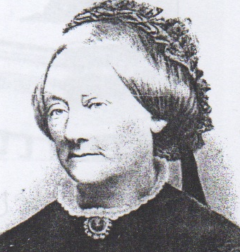
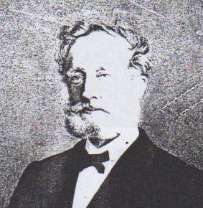

Edward Mayer [1807-1877] and his wife Mathilde de Chazal [1813-1880]

- 2. George Clifford Mayer [1837-1900], Edward Mayer [1807-1877]’s son

George’s life paralleled Queen Victoria’s reign. He may have witnessed the last public execution in Mauritius, which was a beheading of a convicted murderer in 1849. [Not having a guillotine it was done rather more messily with an axe.] Life-long friends were his cousins Pierre Edmond de Chazal and John Rouillard. The three were to marry four sisters, who were their first cousins, all of them being daughters of Edmond de Chazal of St Antoine. At the age of nineteen George won the much-coveted Royal College English scholarship which enabled him to study for a profession in UK. He left for England in 1856, hoping to take part in the Crimean war before beginning his university studies, however the war was over by the time he reached London. He then studied at the Middle Temple and qualified as a barrister.

George expected to marry Lucie de Chazal [1843-1920], one of Edmond de Chazal’s daughters. However George’s absence from Mauritius failed to make Lucie’s heart grow fonder. George’s best friend, Pierre Edmond de Chazal, wrote from Mauritius to say he planned to marry Lucie, who by the way was only 13 years old, provided George did not mind. Luckily for me, because otherwise I would not exist, George gave Pierre Edmond his blessing. George was not overly concerned. Other attractive de Chazal sisters were due to come of age, and in fact he subsequently married two of them, [although of course not at the same time]. Antoinette Eugénie Berthe de Chazal [1856-1891], usually known as Berthe, was second of these two. She married George in 1881 and subsequently she gave birth in 1886 to my grandfather, Ralph Mayer.

Interestingly, both George and Lucie were later on the record as being sufferers of ‘le petit mal’ or mild epilepsy, which is another good reason that they did not mix their genes.

The first of Lucie’s younger sisters that George married was Antonia Virginie de Chazal [1847-1866], but she did not last long. She died in Seychelles after giving birth to her first child. George had been appointed magistrate there. Three years later George returned to Mauritius to take up the post of magistrate of the Flacq district. Later he was to be magistrate of Plaines Wilhelms and then acting Master and acting third Judge at the Supreme Court, Port Louis.

About 1882 George nearly killed himself while absent-mindedly fiddling with a pistol. The “Gazette des Iles de la Mer des Indes” reports that “the Judge George Mayer lost an eye while cleaning a gun on the train, as he thought it was unloaded”

George and his second de Chazal wife lived in Vacoas at Trait d’Union. [which means ‘hyphen’ in English]. The name ‘Trait d’Union’ came from the fact that his house and garden ‘joined’ one called ‘La Mauvrais’ owned by John Rouillard, who was married to Berthe’s sister Edmée de Chazal, and one called ‘Mesnils aux Roses’ owned by Pierre Edmond de Chazal, [who was married to Berthe’s sister Lucie de Chazal].

George’s second wife, Berthe, produced the following offspring at ‘Trait d’Union’.

  - Clifford Anthony Mayer [1883-1960] who was a laureate of Royal College, and who would marry Amélie Jeanne de Chazal [ 1892-1981],
  - Mildred Alice [1885-1957] who would marry Edward [Ned] Lewis Colin Rogers.
  - Ralph George Mayer [1886-1934] who would marry Rita Hunter in 1911 at Taba N’chu, Orange Free State and would become my grandfather.
  - Norman Edward Mayer: [1888-1954] who was a laureate of Royal College who would marry Sabine Yvonne de Chazal [1890-1972]
  - Sybil Eugenia Mayer [1889-1945] who would marry Edgar Piat.
  - Frank de Chazal Mayer [1891-1915] who was a laureate of Royal College, and who would be killed in the First World War.
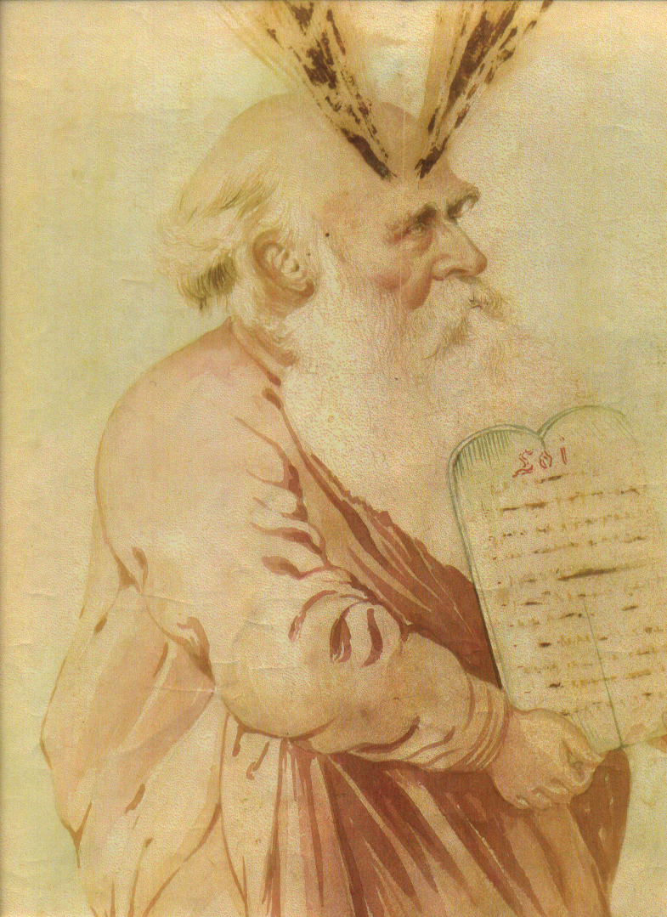
After producing Frank, Berthe died from tetanus, [apparently rather horridly with lots of screaming through clenched teeth and convulsions] and George’s sister Alice (commonly known as Tante Alice or Titale) took over the role of bringing up her children. [My uncle George Mayer maintained that Berthe died because the doctor who attended her during the birth of Frank did not bother to wash his hands after stabling his horse, before seeing to Berthe].

Both the de Chazals and Mayers have a propensity towards mysticism and spiritualism. Antoine de Chazal, George’s father-in-law persuaded George to become a Swedenborgian. In fact Antoine persuaded most of his family to believe that “Swedenborg was the Messenger of the second coming of the Lord through the revelation of the Internal sense of the word.” George’s sister Alice followed George’s example and together they studied this theology. George expounded on it at home and at the New Jerusalem Society meetings. He was one of the leading lights, being elected Mauritius’s leader and president in 1863. His son, Norman Mayer, and one of his nephews, Norbert Rogers, became Swedenborgian priests. The cartoon was painted in 1900 by Lanée to celebrate George Mayer’s religious bent and his contribution to the law in Mauritius. It is entitled “Moϊse donne les tables de la loi” (Moses gives the tablets of the law). There are several good articles on the de Chazal web site about the Swedenborg, so I will not elaborate on the religion further.

3. Clifford Anthony Mayer (1883-1960), George Clifford Mayer’s eldest son.

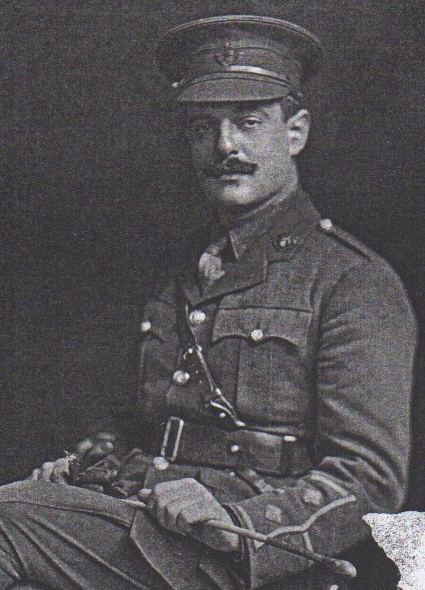
My great uncle, Clifford Anthony Mayer (1883-1960), won the Royal College scholarship that took him from Mauritius to Guy’s Hospital in London where he qualified top of his class and became a surgeon. His first job was Chief Medical officer and personal doctor to the Gaikwar of Baroda, India. Virginia Taylor writes: “As soon as he arrived at the Maharajah’s palace which was a large imposing edifice with onion domes, marble verandahs, archways and pillars, surrounded by beautifully kept gardens, he was rushed down innumerable corridors carpeted with priceless Persian rugs and through halls, hung about with displays of art treasures and ancient weapons, to the women’s quarters. There, surrounded by wailing females, lay the five-year old heir to the throne with cotton wool stuffed up his ears and nose to keep out the evil spirits”

Justifiably or not, Clifford got the credit for the Prince’s recovery and was an immediate hit. He had a wonderful time, playing polo, hunting tigers, attending the 1911 Durbar for George V and Mary, the Emperor and Empress of India, and being part of the Maharajah’s entourage on several trips to Europe.

He took leave to join the British army, serving as a surgeon in the Dardanelles in the Gallipoli campaign in 1915. In the 1920s he left Boroda and set up a successful private clinic with a Dr Ferriere in Curepipe, Mauritius. (I had my tonsils taken out in this clinic in 1950).

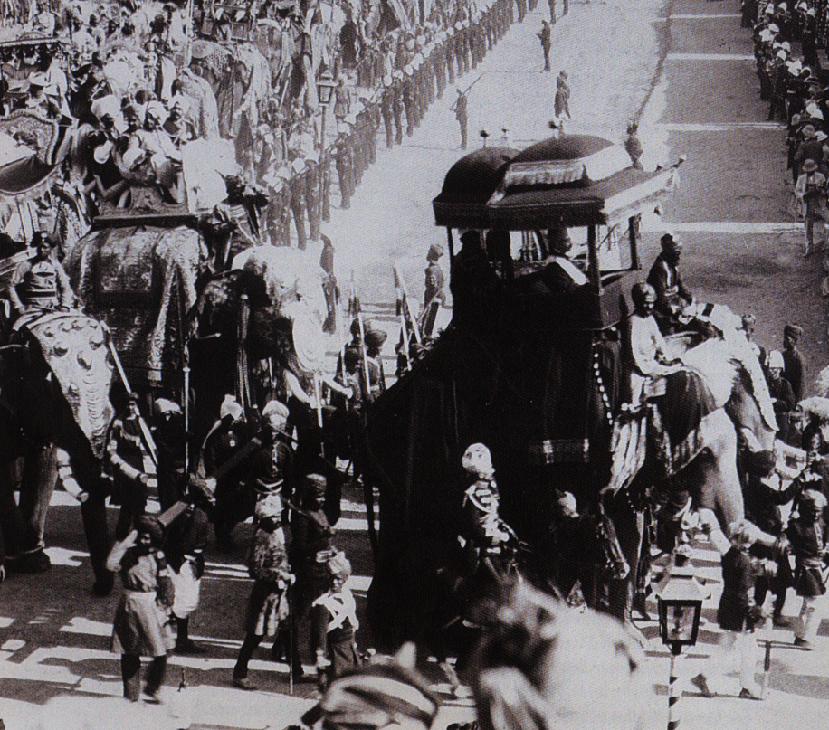
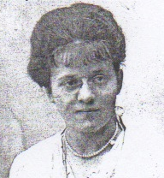

The 1911 Durbar and Jeanne de Chazal

Clifford married an English girl called Muriel Raymond Care, but she cuckolded him, and he divorced her.

Next time round he chose someone who he thought would be more trustworthy – a de Chazal cousin! She was Amélie Jeanne de Chazal [ 1892-1981], commonly referred to as Jeanne, and she gave Clifford four children, Berthe, Renée (better known as Batcha), Jeanne, and Anthony (better known as Toto). The first of these children, Berthe Marcel Clifford Mayer [1913-1981], married a Mayer cousin with de Chazal blood, Percy Mayer [1903-1985]. Both of them were awarded British and French gallantry medals for clandestine operations during World War II, as were Percy’s brother Edmund Richard (better known as Dicko). Another brother James Andrew Mayer was captured in occupied France by the Germans and died in Buchenwald concentration camp. The de Chazal website ‘portrait gallery’ has a very good article about Batcha.

4. Mildred Alice Mayer [1885-1957], George Clifford Mayer’s eldest daughter.

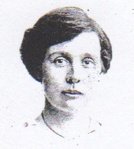
In 1909 Mildred [see above photo] married Edward [Ned] Lewis Colin Rogers. Ned farmed in partnership with my grandfather, Ralph Mayer, in Orange Free State, South Africa, until Ralph married Rita Hunter and decided to return to London and study medicine. Ned’s brother had married Madeleine de Chazal, who was Mildred’s first cousin. There is also another de Chazal connection. Mildred’s great friend in Mauritius was her first cousin, Liline de Chazal. Mildred invited Liline to South Africa and succeeded in pairing her off with a certain Walter Richards, who had been unsuccessfully courting Rita Hunter, my grandmother-to-be. For a while the Richards and the Rogers farmed in partnership.

Mildred had a rather Spartan and obsessive personality, and favored unorthodox medical practices. She was even accused by her relatives of starving her children. In fact the diets that she subjected her offspring to may have contributed to the early death of her youngest daughter, Joy. However she had two other children, Yvelyn and Norbert, who successfully reached maturity and eventually gave Mildred 23 grand children.

5. Ralph George Mayer [1886-1934], George Clifford Mayer’s second son.

After finishing secondary school, my grandfather Ralph George Mayer (1886-1934) chose engineering as a first career. [Unlike his brothers, who won the Royal College Scholarship and had their studies paid for by the Mauritian Government, Ralph came second and received no financial assistance for his education]. To do this he left Mauritius to go to the City and Guilds’ College of Engineering in London, but in England he was found to have incipient tuberculosis and advised to go and live in a dry climate. As a consequence he tried farming with his sister Mildred (née Mayer) Rogers and her husband in Orange Free State, South Africa. He recovered, and met and married my grandmother Marguerite (Rita) Hunter there. Rita encouraged him to return to London and study medicine instead. His training at Guy’s Hospital was interrupted in 1914 when he joined the army. After three years in the trenches he managed to extract himself on the pretext that he was going to finish off his medical studies. Certainly there would have been a shortage of doctors to cope with the millions of wounded soldiers.

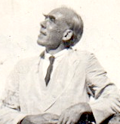
However Ralph was unable to concentrate on his medical studies again. Instead of staying at Guys he returned to Mauritius and did a diploma in chemistry at Reduit College (later to become the University of Mauritius).

With this qualification he obtained industrial chemical work at the sugar factories at the St Antoine (owned by his cousin Rivalz de Chazal), Beau Sejour, Bon-Air, Solitude and the Bois-rouge sugar estates. Later he bid successfully for a contract to provide sand for the filter beds for Mauritius’s drinking water. He gave a lower quote than the previous contractor and was to supply the sand for three years. At the end of a few months he was told to stop as he had provided more than enough sand for decades. The previous contractor had been dishonest.

Because Ralph had saved the Government substantial expense he was able to obtain recompense by way of a grant to go back to London and finish his medical studies. He finally qualified in 1929, returned to Mauritius and began working as a house surgeon at the Government hospital at Candos, (where I remember having my broken arm put in plaster as a child). Later Ralph specialized as an anesthetist.

It was in this capacity, while assisting with his wife’s (i.e. my grandmother’s) hysterectomy that Ralph noticed a small growth. When he mentioned this later to the surgeon, the surgeon decided that a second operation should be done. This was carried out several weeks later and the growth had developed into a substantial malignant tumour. The removal of it allowed my grandmother to live 45 to 50 years more than she otherwise would have.

Unfortunately Ralph own health was not good. He had become run down, perhaps because of exposure to gas during the war, perhaps because he was a heavy smoker, or perhaps because of a TB relapse. He died aged only 48, ostensibly from pneumonia after several bouts of dysentery, malaria and other complications.

6. Norman Edward Mayer: [1888-1954], George Clifford Mayer’s third son.
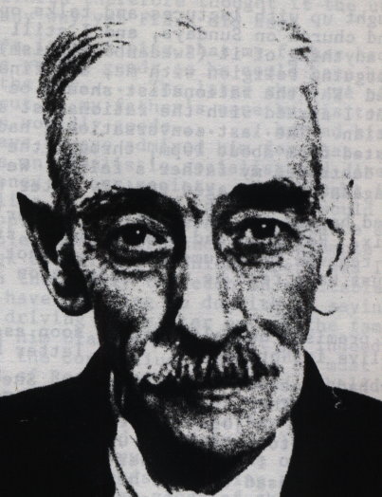
Without much effort Norman Mayer won the Mauritius Royal College scholarship to study in UK. He attended Christ’s College Cambridge and completed his BA and LLB degrees in 1911. While a student he also fathered an illegitimate daughter called Gladys Peggy Mayer Thompson, which Evelyn Mayer, his aunt, and her husband, Monsieur de Saint Pern, adopted and brought up in Lausanne.

Norman decided he did not want to practice law and joined the British consular service instead. He married his cousin Sabine Yvonne de Chazal [1890-1972] in 1914. She had been brought up in Madagascar and he had not seen her for about a decade before they re-met to get married.

In the same year he enlisted in the 10th Battalion Royal Fusiliers with his brother Ralph, and they served together in the trenches in the Artois region of France.

As previously mentioned, Ralph managed to get away from the battlefield by applying for leave to continue with his medical studies, and Norman survived by getting a job as a dispatch rider, and later was commissioned and became a military education lecturer, which meant he was mostly away from the front line. Yvonne followed Norman to France, sometimes being only three miles behind in the trenches. Their children were Polo [1915 - ..], Jano [1919 -..], George Emanuel (Manu) [1920-1983], Francis (or Frank) [1924 -..], and Jacques (or Jakes) [.. -..] and a daughter who died young.

After the war Norman studied Swedenborg’s theology at Manchester and was ordained as a minister. Lucien de Chazal was probably a deciding factor. When he heard that Norman and his nephew Maurice de Chazal both wanted to be New Church ministers he created a fund (£300 a year each) to supplement the stipend the New Church was offering their ministers.

Norman’s first parish was in Lausanne. He built a house for Tante Evelyn and his daughter Gladys there, and socialized with Laurence de Chazal, Norman and Yvonne’s mutual first cousin, who was married to Charles Moubray. Family lore is that Norman had a scandalous affair with Laurence’s daughter Madeleine, and as a result Norman had to pack up and go. Norman took his family to live in Paris.
In 1940 Norman’s son Pol Mayer was in the French Army and was captured by the Germans at Dunkirk. Another son, Jan Mayer was amongst the French and British troops at Narvik but he had managed to get back to England. Meanwhile Norman and the rest of his family joined the columns of desperate refugees feeing from the German advance.

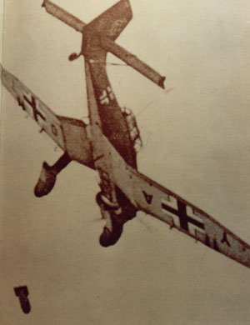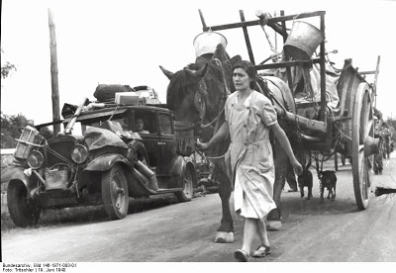

Norman’s son Frank writes “Progress was very slow as the road was jammed solid with refugees, mostly women, old men and children. I was then 16 years old. The few lucky ones had carts or wheelbarrows but the majority carried their few possessions as best they could. The Germans strafed the crowd daily, and occasionally dropped bombs from stukas. Diving into ditches reduced casualties though one boy was killed next to my mother.”

Norman and his sons Frank and Manu escaped to England, but Yvonne and Jacques remained in France. More of this family’s story can be read in the article by Norman’s son Frank in ‘Portraits’ on the de Chazal website.

7. Sybil Eugenia Mayer [1889-1945] George Clifford Mayer’s second daughter.

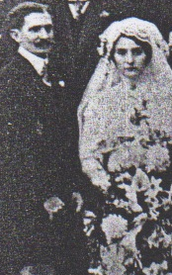

Sibyl was keen to marry her first cousin, Marcel de Chazal, but inconveniently he was drowned when the ship he was on was wrecked during a cyclone. Subsequently she married Edgar Piat and had two children called Roger and Sibyl (also known as Mimi). The adjacent photo is of Sybil and Edgar Piat at their wedding. They took over, and lived in, Trait d’Union.
According to my grandmother, Sybil’s marriage was unhappy, no doubt in part because she was really a lesbian.

8. Frank de Chazal Mayer [1891-1915], George Clifford Mayer’s fourth son.

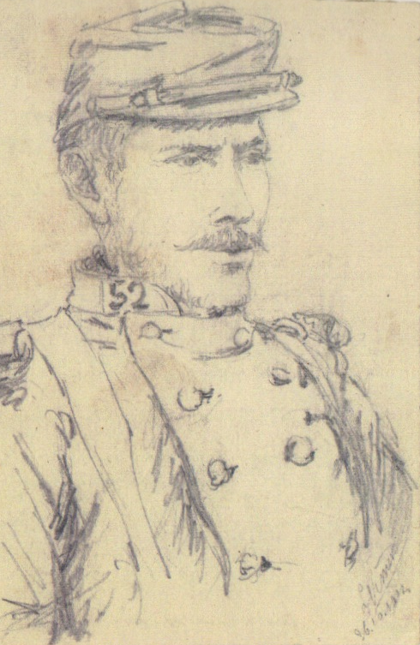
Frank started studying agricultural engineering at Christ’s College, Cambridge, after having won ‘the English Scholarship’ of the Royal College in 1911.

When World War one began he was heading for Switzerland to visit de Chazal relatives on his bicycle. Anxious to participate, and worrying that the war might be over soon, he did not bother to return to England but instead enlisted immediately in the French army, specifically the 10th company of the 52nd infantry regiment. Army despatches about an action on 31 October 1914 mention him “for his bravery and his courage during the attack on a German trench and his killing of four of the enemy”. He was subsequently awarded the Croix de Guerre. Jean Brouard in ‘The dictionary of Mauritian Biography’ states that “On 21 September 1915 at Parthus-les-Hurlus (Marne) he took off his helmet to wipe his brow and was killed by a bullet through the head”. This is not quite true. The ‘instant death’ was a fabrication, which was subsequently relayed to Brouard. It had been told to sooth the feelings of some near relatives. A letter between Frank’s Paris-based aunt, Marguerite Tuffier (née de Chazal), and her brother-in-law Clifford Mayer, plus a letter from Doctor-Major Gayet of the French Army have since come to light. They tell a grimmer story.

Gayet says ‘Sergeant Frank Chazal Mayer, was brought in my ambulance in a very sorry state - he had received multiple pieces of shrapnel, which caused a double fracture of the right leg, a fracture of the left leg, a head wound. He was in a coma and did not regain consciousness. His state allowed no intervention, although we tried hard to resuscitate him by injections of serum, camphor oil, etc. He died September 22nd at six o’clock in the morning, 12 hours after his arrival.’

Currently Frank’s remains lie in the Ossuaire de Nécropole Nationale de Somme-Suippe, and his name also figures on the Royal College’s cenotaph at Curepipe, Mauritius. Other than rubble and shell craters nothing is left of the village of Parthus-les-Hurlus.

My uncle T K [Tommy] Mayer deposited Frank’s letters and sketches from the front in the Imperial War Museum, Lambeth Road, London, in 1980. Recently I was browsing in a Wellington bookshop and spotted a new book about WWI by a well-known author, Max Hastings, who no doubt wrote it because he knew it would sell well, 2014 being the centennial of the start of the war. It is called 'Catastrophe - Europe goes to war 1914'. I found Frank’s photo next to page 507. Max Hastings calls him François Mayer, and quotes him several times as giving a French soldiers viewpoint. In the credits at the back of the book, Hastings refers to 'Imperial War Museum' [IWM] Mayer François.

In 1980 the war museum’s manager of documents wrote to my uncle Tommy Mayer, (who was Frank’s nephew), that " Your uncle's descriptions of conditions in the trenches and his thoughts about the war, the French army and the German foe make the collection a rich source of information which is bound to be of value to many scholars in the course of their research". Obviously Hastings has been one of those scholars, although not a particularly thorough one. He referred to Frank's letter to his wife when in fact they were to his aunt [Tante Alice] who brought him up, and did not bother to mention that Frank was British even though he wrote his letters in French.

George Mayer [1912 -1999], Ralph George Mayer [1886-1934]’s eldest son.

George, my uncle, was born in London, but spent his early childhood in Mauritius and South Africa. He was partly educated in South Africa, and worked for a while in the Mauritius Forest Service. I identify with the latter fact because my own career has been in forestry. George rose to the rank of major and saw action in the Western Desert during the Second World War. In 1945 he married his cousin Pauline de Chazal [1916- 2009] and studied local government at the London School of Economics. This led to management work in the Labour Department in Seychelles and Mauritius. Later, with Pauline, he became hotel manager at Grande Baie. George and Pauline had three daughters, Françoise, Mathilde and Suzanne.
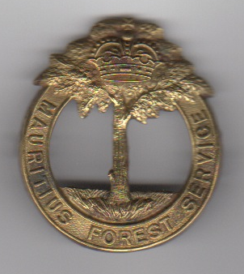
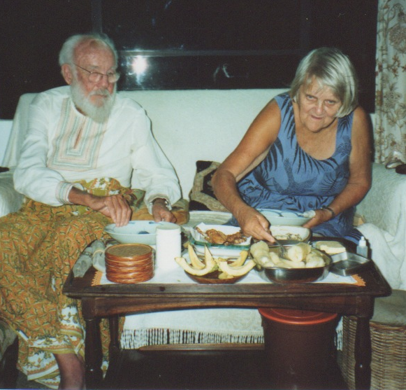

George and Pauline in Mauritius in 1991. George’s Mauritius Forest Service cap badge circa 1937

Acknowledgement: I am grateful to my first cousin, Mathilde Spall, [George and Pauline’s daughter], for checking and making useful additions to this essay.

Bibliography:

Binney Marcus : 2002 ‘The women who lived for danger: Women Agents of SOE in the Second World War. Hodder and Stroughton.
De Chazal Marc: “Lettres de Marc de Chazal à son Père Pierre Edmond de Chazal 1900-1903.
De Chazal Pierre Edmond. “Journal de Pierre Edmond de Chazal 1854-1859.” (Introduction by Pauline Mayer (Née de Chazal).
Gayet ? Doctor-Major: October 1915: letter to Margaruite Tuffier (née de Chazal)
Hastings Max: 2013: 'Catastrophe - Europe goes to war 1914'. William Collins.
Levack Hamish: 2006: ‘Empire, Enlightenment and Family’.
Mayer Frank de Chazal: “Letters and Journal from the French Front 1914-1915: [Includes commentary by his nephew T K (Tommy) Mayer 1991.]
Mayer Geo (Manu) : 1992 An English Terror Flieger”
Mayer T K (Tommy) : 1989: ‘The Mayer Story 1575-1929’.
Mayer T K (Tommy): ‘Ralph and his siblings –The Trait d’Union Mayers 1883-1960’.
Taylor Virginia: 1985: “Two Families of Ile de France”.
Tuffier Margaruite (née de Chazal): 3 October 1915: Letter to Clifford Mayer.

